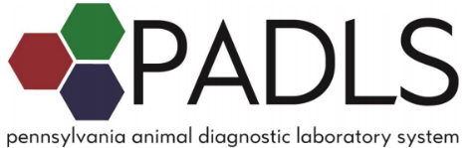

2022 Practitioners’ Meeting
Hosted by the Animal Diagnostic Laboratory at Penn State University
Emphasis on Diseases of Small-Scale Swine Production
Tuesday April 26, 2022, 8:30a – 4:30p
Location: In person – Room F, Bryce Jordan Center, University Park, PA
Or live on Zoom
Cost: FREE

8:30-9:15 Welcome, ADL updates, and Summary of Swine Cases at ADL
Erin Luley, VMD, MPH, DACVP – Mammalian Pathologist, Penn State ADL
9:20-10:20 Swine reproduction and biosecurity
Beth Hines, PhD – Swine Specialist, Penn State Extension
10:25-11:25 Swine viral diseases – Clinical signs, vaccination, and prevention
Brigitte Mason, DVM – Field veterinarian, Country View Family Farms
11:30-12:00 Biosecurity plans
Aliza Simeone, VMD – Pennsylvania Department of Agriculture Region 7 Veterinarian
12:00-1:00 Lunch

1:00-1:45 Regulatory updates from the Pennsylvania Department of Agriculture
Kevin Brightbill, DVM – Pennsylvania State Veterinarian, PA Dept. of Agriculture
1:50-2:20 Highly pathogenic avian influenza
Megan Lighty, DVM, PhD, DACPV – Avian Pathologist, Penn State ADL
2:25-2:55 Seasonal trends in diseases at ADL
Katie Kelly, DVM, PhD, DACVP – Mammalian Pathologist, Penn State ADL
3:00-4:00 Serology interpretation
Suresh Kuchipudi, DVM, MVSc, PhD, FHEA, DACVM, MBA – Associate Director and Head of Microbiology, Penn State ADL
4:05 -4:30 Region 5 updates
Jen Johnson, Dawn Dilling – Pennsylvania Department of Agriculture Region 5 Domestic Animal Health Inspectors
4:30 Meeting adjourns
*Agenda subject to change*
Continuing education credits will be available. Certificates will be emailed following the event. Recordings and speaker handouts will be available in a shared folder
In person registration: Call 814-863-0837 or email ehl5008@psu.edu
Zoom registration: https://psu.zoom.us/webinar/register/WN_OrRmCkUyTsSVj8Kzt75DSg
